**ECE 442 Lab 4**

**Ryan Brooks, ID: 1530605**

1. The optimum threshold value is 0.271.

Please see attached images Q1Optimum.bmp and Q1Mean.bmp

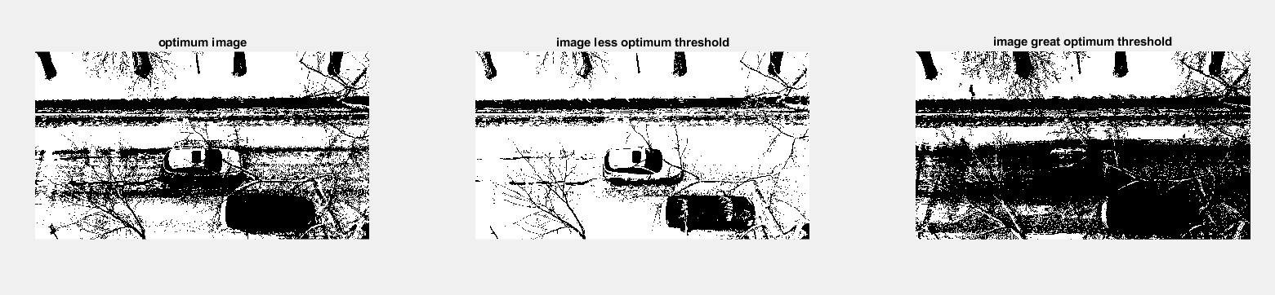

As we increase the threshold, we can see that some features that would be required for the foreground start to disappear. As the threshold is decreased, we can see an increase in unnecessary features such as the parked car.

1. See below for a sample generated MOG using K = 5.

Note: these numbers will change as there is an element of randomness to generating a MOG

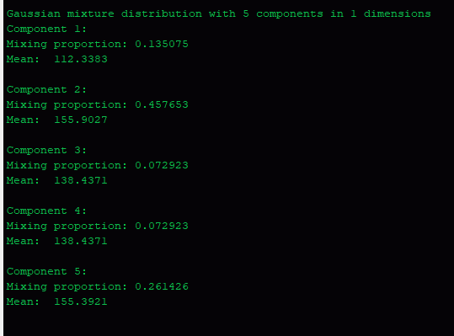

1. The minimum value of threshold determined was 0.0595 for one run
2. As seen below as the value for K increases our threshold gets smaller. This suggests that as we increase K we will get a more accurate depiction of foreground vs background pixels.



1. Please see the files that start with the name thresh. They all correspond to foreground and background images per threshold values (0.0001, 0.001, 0.01).

These images seem to be flipped (i.e. background looks more like what we would expect for the foreground), however, I am not sure why this is happening as I have followed the if probability < threshold then the pixel belongs to the foreground

Note: this section takes about 2 hours to run to completion.

1. Not attempted.